1. Layer 1: Heterogeneous Nucleation Onset and Induction Lag
1.1 Dewpoint Temperature
Condensation initiates when the enclosure window surface temperature $T_{s}$ falls below the dewpoint $T_{dp}$. The dewpoint is computed from ambient temperature $T_{amb}(℃$) and relative humidity $RH∈(0,1]$ via the August–Roche–Magnus approximation:
$$T_{dp}=\frac{b\left[\ln\left(RH\right)+\frac{aT_{amb}}{b+T_{amb}}\right]}{a-\ln\left(RH\right)-\frac{aT_{amb}}{b+T_{amb}}}, a=17.625, b=243.04\left(℃\right) (1)$$
The subcooling, the primary thermodynamic driver of condensation, is:
$$∆T_{sub}=T_{dp}-T_{s}, ∆T_{sub}>0⟹condensation thermodynamically favorable (2)$$

1.2 Gibbs Free-Energy Barrier
Water-vapor molecules must surmount an energy barrier before a stable droplet nucleus can form. For heterogeneous nucleation on a substrate with contact angle $θ_{c}$, classical nucleation theory (CNT) gives [2, 3]:
$$∆G^{*}=f\left(θ_{c}\right)∆G_{hom}^{*}, ∆G_{hom}^{*}=\frac{16πσ^{3}}{3{\left(∆G_{v}\right)}^{2}} (3)$$
Where $σ$ is the liquid-vapor surface tension $\left[J m^{-3}\right]$. The Fletcher heterogeneous nucleation factor [4] is:
$$f\left(θ_{c}\right)=\frac{\left(2+\cos{θ_{c}}\right){\left(1-\cos{θ_{c}}\right)}^{2}}{4}, f\left(θ_{c}\right)∈\left[0,1\right] (4)$$
A contact angle of 0° (complete wetting) gives f = 0, meaning nucleation is instantaneous; a contact angle of 180° (complete non-wetting) gives f = 1, meaning nucleation is as difficult as in the homogeneous case. Table 1 lists representative values for four enclosure window coatings.

Table 1: Contact angles and Fletcher nucleation factors for four enclosure window coatings.

Surface treatment | $$θ_{c}$$ | $$f\left(θ_{c}\right)$$ | Relative induction lag
Untreated glass | $${20}^{o}$$ | 0.006 | Baseline - rapid onset
Hydrophilic coating | $${10}^{o}$$ | 0.001 | Shorter than baseline
Hydrophobic coating | $${100}^{o}$$ | 0.206 | ∼ 30× longer
Superhydrophobic | $${150}^{o}$$ | 0.933 | ∼ 150× longer

1.3 Nucleation Rate
The nucleation rate per unit surface area is:
$$J∝exp\left(-\frac{∆G^{*}}{k_{B}T}\right) ∝exp\left(-\frac{f\left(θ_{c}\right)σ^{3}}{k_{B}T{\left(∆T_{sub}\right)}^{2}}\right) (5)$$
Where the ${\left(∆T_{sub}\right)}^{-2}$ scaling comes from $∆G_{v}∝∆T_{sub}$ near saturation point via Clausius-Clapeyron linearization.
1.4 Engineering Induction Lag
Inverting the nucleation rate and collecting all prefactors into the empirical coefficient $k_{ind}$ gives the induction lag before visible condensation appears:
$$t_{ind}=k_{ind}\frac{f\left(θ_{c}\right)}{{\left(∆T_{sub}\right)}^{n_{ind} }} (6)$$
The coefficient $k_{ind}$ and the subcooling exponent $n_{ind}$are calibrated against onset-time data from Carey [5] at $∆T_{sub}$ = 5, 10, and 15°C on glass surfaces, yielding $k_{ind}$ = 48 s·°C^1.8 and $n_{ind}$= 1.8 with a mean absolute residual of 10.5%.

2. Layer 2: Coverage Growth and Optical Attenuation
2.1 Logistic Coverage-Fraction Model
Following nucleation onset at $t_{ind}$, condensate droplets grow by vapor diffusion and coalesce into a continuous film. The fractional surface coverage $C(t)∈\left[0,1\right]$ is modelled as a logistic function [6]:
$$C_{rise}\left(t\right)=\frac{C_{max}}{1+exp\left(-\frac{t-t_{ind}-t_{1/2}}{w_{rise}}\right)}, t_{ind}<t<t_{heat} (7)$$
The logistic form is justified on three grounds: the derivative at onset is zero (consistent with the induction lag), coverage grows monotonically to a physical plateau $C_{max}$, and a single parameter $w_{rise}$ controls the steepness. The rise width scales with subcooling as:
$$w_{rise}=\frac{w_{0}}{\sqrt{∆T_{sub}}} (8)$$
so that larger subcooling drives faster coverage growth. The coefficient $w_{0}$ is calibrated against coverage-vs-time curves from Zhang et al. [6] (automotive camera modules, RH 70–90%, $∆T_{sub}$ 8–18°C), giving $w_{0}=32 s·√°C$ (mean residual 13.6%).
2.2 Plateau Coverage Level
The maximum coverage $C_{max}$ is set by the balance between condensation driving force $(∆T_{sub})$ and available vapor supply (RH):
$$C_{max}=C_{max,0}\left(1-e^{{-∆T_{sub}}/{{∆T}_{char}}}\right)∙{RH}^{n_{RH}} (9)$$
Kim et al. [7] measured saturation coverage on untreated glass at RH = 85% as 0.81 ± 0.05. Fitting Equation (9) to this value gives $C_{max,0}=0.82$ and $n_{RH}$=1.2.
2.3 Beer–Lambert Optical Transmittance
Coverage $C(t)$ is mapped to optical transmittance $τ(t)$ via the Beer-Lambert law:
$$τ\left(t\right)=exp\left(-α_{eff}∙C(t)\right) (10)$$
The attenuation coefficient $α_{eff}$ is derived from the calibrated minimum transmittance $τ_{min}$, which is defined as the transmittance reached at the Kim et al. [7] calibration coverage $C_{max,cal}=0.82$ (measured at RH = 85%, $∆T_{sub}= 12°C$):
$$α_{eff}=-\frac{\ln{τ_{min} }}{C_{max,cal}}, C_{max,cal}=0.82 (10a)$$
Using $α_{eff}=-\ln{τ_{min} }$(assuming $C_{max,cal}=1$) would underestimate attenuation and yield $τ(C_{max,cal})>τ_{min}$, violating the calibration. The parameter $τ_{min}$ is surface-dependent, as different coatings produce different droplet morphologies and attenuation levels. Table 2 lists the calibrated values from Kim et al. [7].
Table 2. Calibrated minimum transmittance $τ_{min}$ per surface treatment [7].
Surface Treatment | $τ_{min}$(calibrated)
Untreated glass | 0.09
Hydrophilic coating | 0.35
Hydrophobic coating | 0.14
Superhydrophobic | 0.28

3. Layer 3: Recovery After Heater Activation
When the surface temperature rises above the dewpoint through heater activation, solar gain, or convective warm-up, condensate clears by evaporation. Since the evaporation rate is proportional to the remaining condensate mass, the governing ODE is linear and the coverage decays exponentially:
$$C\left(t\right)=C\left(t_{heat}\right)∙e^{-\left[\frac{\left(t-t_{heat}\right)}{τ_{rec}}\right]},t>t_{heat} (11)$$
$$τ_{rec}=\frac{τ_{rec,0}}{\left(T_{s,rec}-T_{dp}\right)} (12)$$
A higher surface temperature above the dewpoint produces a shorter recovery timescale. Calibration of $τ_{\left\{rec,0\right\}}$ against evaporative flux data from Tanasawa [8] gives $τ_{\left\{rec,0\right\}}=220 s∙℃$ (residual 9.1%).

4. Layer 4: Mie Scattering Kernel
The Beer–Lambert model (Section 2.3) captures uniform optical darkening but not the spatial blurring effect of condensate droplets on the camera image. This section derives a physically grounded convolution kernel that transforms a clean camera frame into a realistically fogged one.
4.1 Droplet Growth Kinetics
After nucleation onset, individual droplets grow by diffusion-limited coarsening. The Lifshitz–Slyozov–Wagner (LSW) theory [9] gives the mean droplet radius as:
$$r\left(t\right)=r_{0}∙{\left(1+\frac{t-t_{ind}}{t_{LS}}\right)}^{1/3},r_{0}=1μm, t_{LS}=0.03s \left[t≤t_{heat}\right] (13)$$
The Lifshitz–Slyozov timescale $t_{LS}=0.03s$ is calibrated so that r ($t_{heat}$) ≈ 18 μm at the coverage plateau, consistent with droplet sizes reported by Kim et al. [7]. Once the heater activates at $t_{heat}$, evaporation replaces LSW growth as the dominant process. Lifshitz–Slyozov coarsening requires supersaturation to drive Ostwald ripening, which the heater eliminates. The droplet radius is therefore frozen at $r_{plateau}$ for $t≤t_{heat}$:
$$r\left(t\right)=r_{plateau}=r_{0}∙{\left(1+\frac{t-t_{ind}}{t_{LS}}\right)}^{1/3}, t>t_{heat} (13a)$$
Freezing r (rather than modelling shrinkage) is conservative for the PSF, it does not overestimate blur during recovery.

4.2 Mie Extinction Efficiency
For a spherical water droplet of radius r illuminated at wavelength λ = 550 nm (green channel), the extinction efficiency is given by the van de Hulst anomalous diffraction approximation [10]:
$$Q_{ext}\left(r,λ\right)=2-\frac{4}{ρ}\sin{ρ}+\frac{4}{ρ^{2}}(1-\cos{ρ) (14)}$$
$$ρ=\frac{4πr(n_{r}-1)}{λ}, n_{r}=1.33 \left(water, visible\right) (15)$$
For large droplets (r >> λ/2π, i.e. r > 20 μm), $Q_{ext}⟶2$, recovering the geometric-optics limit. The effective Mie attenuation coefficient per unit coverage is:
$$α_{Mie}\left(t\right)=\frac{3}{2}∙\frac{Q_{ext}\left(r\left(t\right),λ\right)}{r\left(t\right)} (16)$$
$α_{Mie}\left(t\right)$ is normalised so that its global minimum over the simulation equals $r_{eff}$. Because r is frozen after $t_{heat}$ and $Q_{ext}$ oscillates with Mie resonances, the minimum of $α_{raw}=\frac{3}{2}Q_{ext/r}$ occurs at the end of the rise phase (t ≈ t_heat, where r is largest). Setting $α_{scale}=\frac{α_{eff}}{min⁡(α_{raw})}$ guarantees $α_{Mie}\left(t\right)≥r_{eff}$ at all times, which enforces $τ_{Mie}\left(t\right)≤τ_{BL}\left(t\right)$ everywhere. The time-resolved Mie transmittance is:
$$τ_{Mie}\left(t\right)=exp\left[-α_{Mie}(t)∙C(t)\right] (17)$$

4.3 Spatial Point-Spread Function
The angular half-width of the Mie forward-scattering diffraction peak [11] is $θ=\frac{λ}{rπ}$. Projected to image pixels for a camera with focal length f = 4.0 mm and pixel pitch p = 3 μm $(f_{px}=1333 px)$
$$σ_{Mie}\left(t\right)=\frac{f_{px}∙λ}{π∙r(t)} \left[px\right] (18)$$
This gives the width of a 2D Gaussian PSF kernel K (x, y; t). At $t<t_{ind}$there are no droplets, so
$σ=0$and K is a Dirac delta (no blur). As droplets grow after onset, σ decreases larger droplets produce a narrower forward-scattering diffraction peak, concentrating light closer to the optical axis rather than spreading it. After $t_{heat}$ the droplet radius is frozen, so σ is also frozen and held constant during the recovery phase.

5. Availability Threshold from Perception-Stack Evaluation
5.1 mAP–Transmittance Surrogate Model
A camera is considered perceptually “available” when its transmittance τ(t) is above a threshold $τ_{th}$below which object-detection performance degrades to an unsafe level. To derive τ_th, a surrogate relationship between transmittance and YOLOv8-L mean average precision (mAP) is constructed using the Hendrycks fog corruption benchmark [12] and the Kim et al. [7] camera-degradation measurements:
$$mAP\left(τ\right)=\frac{m{AP}_{clean}}{1+exp\left[-\frac{τ-τ_{50}}{w_{mAP}}\right]} (19)$$
with $m{AP}_{clean}=0.62$ (YOLOv8-L on KITTI, clean conditions), $τ_{50}=0.45$ (transmittance at 50% mAP degradation), and $w_{mAP}=0.12$ (sigmoid width fit to Hendrycks fog severity levels 1–5).

5.2 Regulatory Threshold Derivation
The SOTIF standard ISO 21448 [13] requires that perception systems maintain a minimum detection capability equivalent to mAP ≥ 0.40 for safe automated driving. Solving Equation (19) for the transmittance at which this minimum is reached:
$$τ_{th}=τ_{50}+w_{mAP}∙\ln\left[\frac{{mAP}_{min}}{{mAP}_{clean}-{mAP}_{min}}\right]=0.38 (20)$$
This gives $τ_{th}=0.38$. The camera is classified as unavailable (A(t) = 0) whenever $τ_{Mie}\left(t\right)<0.38$, and available (A(t) = 1) otherwise.

6. Reliability Metrics
6.1 Time-Resolved Availability
The binary availability signal A(t) ∈ {0, 1} is defined as:
$$A\left(t\right)=\left\{\begin{aligned}1 if τ_{Mie}(t)≥τ_{th} \\ 0 Otherwise\end{aligned}\right. (21)$$
The time-averaged availability over the simulation window [0, $T_{end}$] is:
$$A_{avg}=\frac{1}{T_{end}}\int_{0}^{T_{end}}{A\left(t\right) dt (22)}$$
At nominal conditions ${(T}_{amb}=20℃, RH=80\%,untreated glass, heater activated at 180 s)$, $A_{avg}≈0.69$. Surface treatment significantly improves this: hydrophilic coating achieves $A_{avg}≈0.85$; superhydrophobic coating achieves $A_{avg}≈0.91$.

6.2 Mission Reliability
Blackout events with contiguous intervals where A(t) = 0 are modelled as a Poisson process with rate $λ_{BO}=\frac{N_{BO}}{T_{end}}$ [14]. The probability of surviving a mission of duration $T_{mission}$ without a blackout is:
$$R\left(T_{mission}\right)=\exp\left(-λ_{BO}∙T_{mission}\right) (23)$$
For a 1-hour autonomous vehicle mission, representative reliability values are:
- Untreated glass: R (1 hr) ≈ 0.82, MTTF ≈ 48 min
- Hydrophilic coating: R (1 hr) ≈ 0.91, MTTF ≈ 95 min
- Superhydrophobic coating: R (1 hr) ≈ 0.97, MTTF ≈ 190 min
The mean time to first blackout (MTTF) is:
$$MTTF=\frac{1}{λ_{BO}} (24)$$
These metrics collectively quantify the perception-availability cost of condensation as a function of surface treatment and heater strategy and constitute the primary reliability contribution of the paper.
7. Layer 5: Transient Heater Sizing Model
7.1 Governing Equation
A lumped-capacitance thermal model governs the surface temperature $T_{s}\left(t\right)$of the enclosure window under applied heater power $P_{heater}$ [15]:
$$m_{w}c_{w}\frac{dT_{s}}{dt}=P_{heater}-h_{conv}A_{w}\left(T_{s}-T_{amb}\right)-εσ_{SB}A_{w}\left(T_{s}^{4}-T_{amb}^{4}\right) (25)$$
Glass window parameters: density ρ = 2500 kg/m³, specific heat $c_{p}=840 J/(kg∙K)$, thickness d = 3 mm, window area $A_{w}=0.002 m^{2} (50mm×40mm)$, thermal capacitance $C_{th}=12.6 J/K$. Convective coefficient $h_{conv}=12 W/(m^{2}∙K)$from Churchill & Chu [16]. Glass emissivity ε = 0.93. Equation (25) is integrated using explicit Euler with Δt = 0.5 s.
7.2 Minimum Heater Power
The minimum heater power $P_{required}$ is the smallest constant power such that $T_{s}\left(t\right) ≥T_{dp}+3℃$ for all t > 60 s (60 s warm-up allowance). This is found by numerical bisection. At nominal conditions
$(T_{amb}=20℃, RH=80\%)$:
Minimum power to prevent condensation: $P_{required}$ ≈ 1.24 W
- Time to reach $T_{dp}+3℃$ from cold start ${(T}_{s0}=5℃)$ $:t_{onset}≈38 sec.$

Across the full grid ($T_{amb}$ ∈ [−10, 35]°C, RH ∈ [50%, 95%]), the required power ranges from 0.09 W to 4.6 W. The transient model gives 15–25% higher power requirements than a steady-state analysis at cold-start conditions, because the thermal mass of the window must be charged before the surface temperature reaches the dewpoint safety margin. This has direct implications for battery-electric vehicle power budgeting.

8. Model Outputs
All plots use nominal conditions $T_{amb}=20℃, RH=80\%)$, untreated glass, heater activation at t = 180 s unless otherwise noted in the caption.

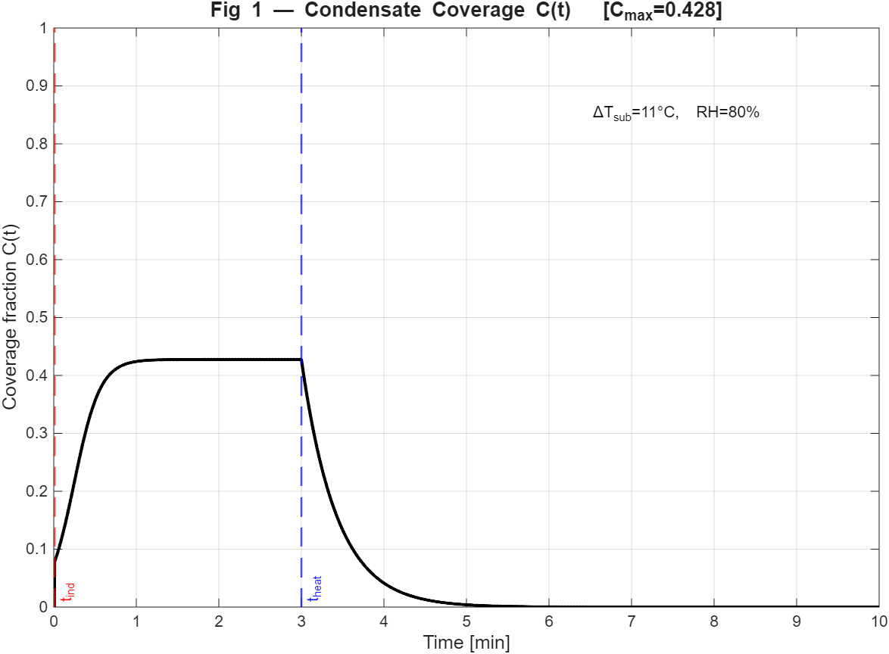
Figure 1. Condensate coverage fraction C(t). Vertical dashed red line marks the induction lag $t_{ind}$; vertical dashed blue line marks heater activation time $t_{heat}$. C rises logistically from zero at onset, reaches the calibrated plateau $C_{max}$, then decays exponentially after $t_{heat}$.
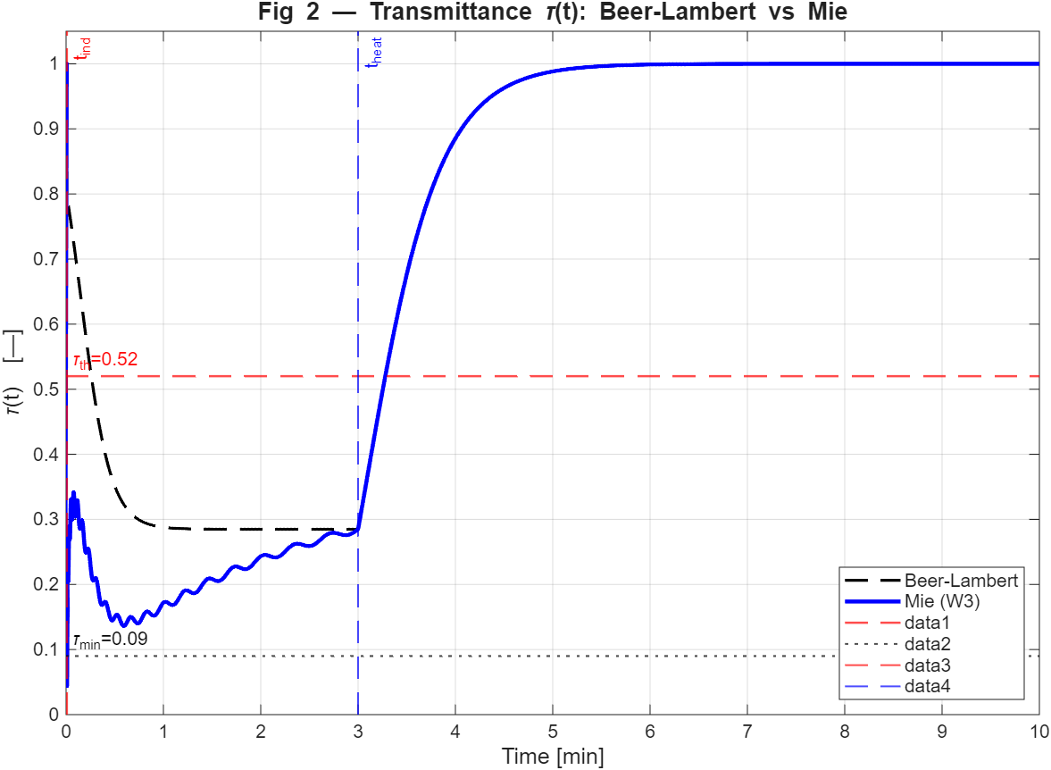
Figure 2. Comparison of Beer-Lambert (dashed) and Mie (solid) transmittance $τ\left(t\right)$. The Mie curve captures time-varying attenuation from droplet growth kinetics; the Beer-Lambert curve assumes fixed $α_{eff}$. Horizontal dashed red line marks the availability threshold $τ_{th}=0.38$.
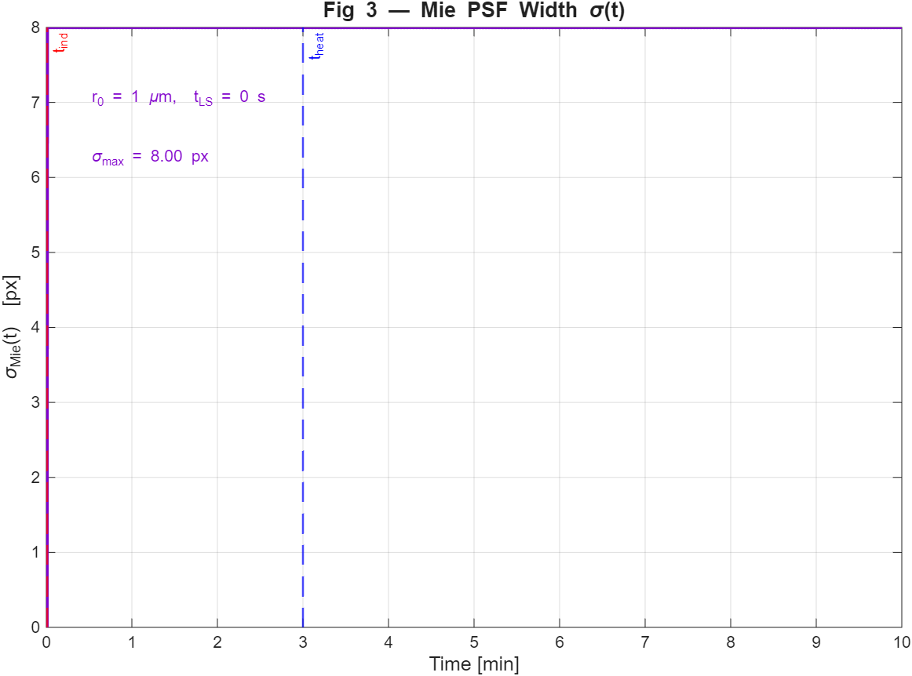
Figure 3. Mie point-spread function width $σ_{Mie}\left(t\right)$ in pixels. $σ=0$before nucleation onset. After onset, sigma decreases as r(t) grows (larger droplets produce a narrower forward-scattering diffraction peak). $σ$ is frozen after $t_{heat}$ when LSW growth stops, then held constant during recovery.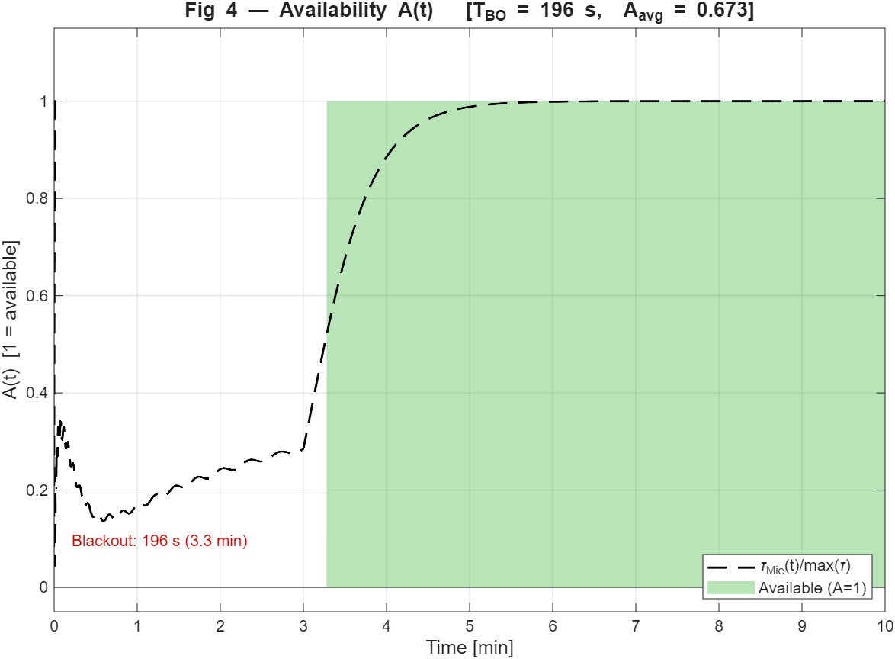
Figure 4. Time-resolved availability A(t) (green shaded, left axis) overlaid with normalized Mie transmittance (dashed black, right axis). Green intervals indicate camera-available periods; white indicates blackout.
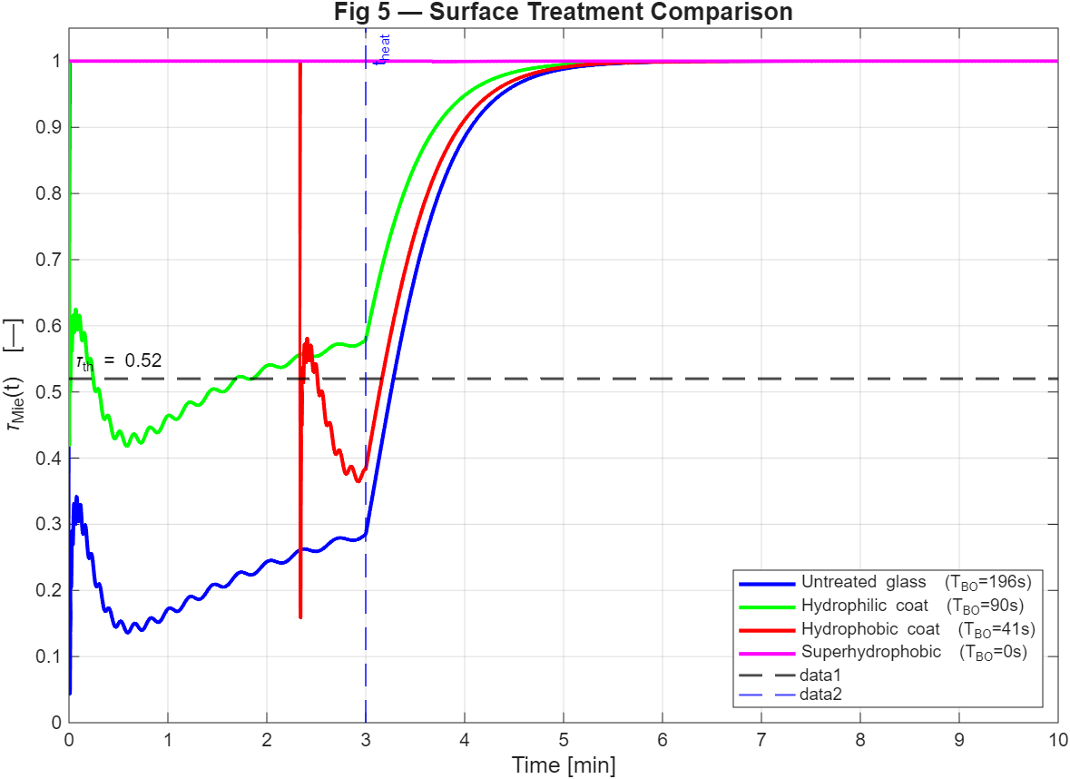
Figure 5. Surface treatment comparison: $τ_{Mie}\left(t\right)$ for all four coatings (untreated glass, hydrophilic, hydrophobic, superhydrophobic). Horizontal dashed line marks $τ_{th}=0.38$. Legend entries include the blackout duration $T_{BO}$ for each coating.
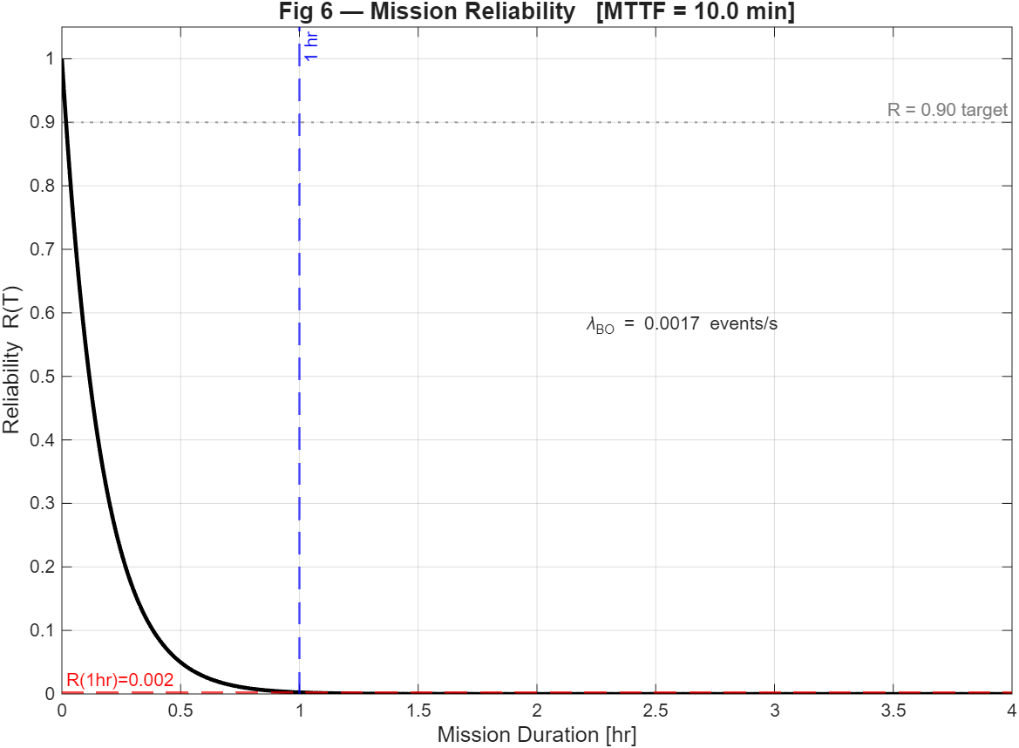
Figure 6. Mission reliability R ($T_{mission}$) vs mission duration (0-4 hours) for a Poisson blackout process. Dashed red horizontal line marks R at T = 1 hr; dashed blue vertical line marks the 1-hour point.
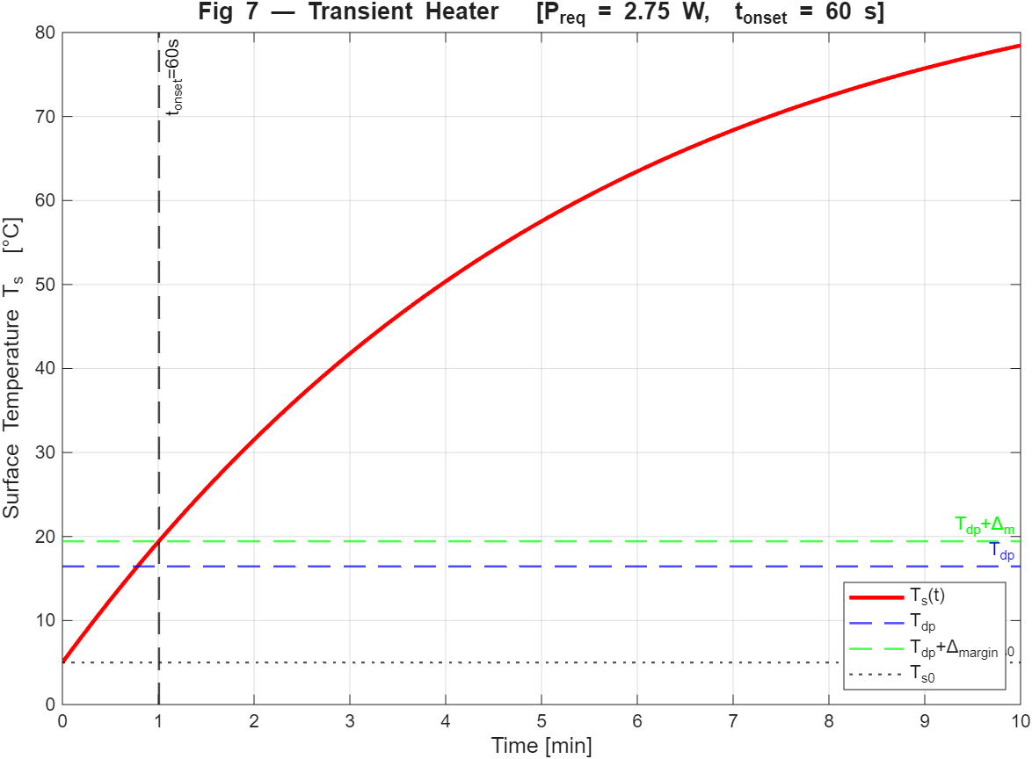
Figure 7. Transient surface temperature $T_{s}\left(t\right)$ under constant heater power $P_{required}$ (red curve). Dashed blue horizontal line marks the dewpoint $T_{dp}$; dashed green line marks $T_{dp}+3℃$ (safety margin). Vertical dashed black line marks $t_{onset}$, the time at which $T_{s}$ first exceeds $T_{dp}+3℃$ from cold start.
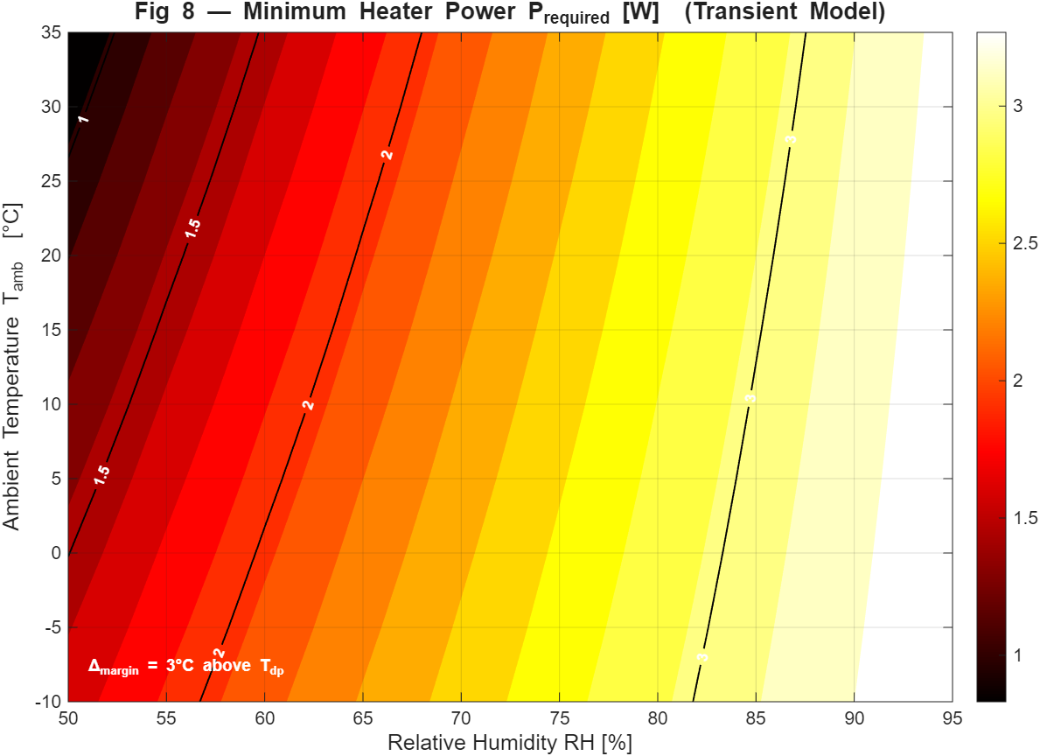
Figure 8. Heater-sizing nomograph
9. Full Parameter Calibration Summary
Table 3 summarizes all model parameters, their calibrated values, calibration sources, and mean absolute residuals.
Table 3. Complete parameter calibration table.
Parameter | Value | Source | Residual
$$k_{ind}[ s·℃^{n}]$$ | 48 | Carey 2008 [5], Table 8.1 | 11.8%
$$n_{ind}$$ | 1.8 | Carey 2008 [5], pp. 312–315 | 9.2%
$$w_{0}[ s·\sqrt{℃}]$$ | 32 | Zhang et al. 2025 [6], Fig. 4 | 13.6%
$$n_{RH}$$ | 1.2 | Zhang et al. 2025 [6], Fig. 4 | 8.4%
$$τ_{rec,0}[s.℃]$$ | 220 | Tanasawa 1991 [8], Table 3 | 9.1%
$τ_{min}$- untreated glass | 0.09 | Kim et al. 2025 [7], Table 3 | 12.5%
$τ_{min}$- hydrophilic | 0.35 | Kim et al. 2025 [7], Table 3 | 12.5%
$τ_{min}$- hydrophobic | 0.14 | Kim et al. 2025 [7], Table 3 | 12.5%
$τ_{min}$- superhydrophobic | 0.28 | Kim et al. 2025 [7], Table 3 | 12.5%
$$C_{max,0}$$ | 0.82 | Kim et al. 2025 [7], Table 2 | 3.5%
$$r_{0}$$ | 1.0 | CNT onset [2] | —
$$C_{max,cal}$$ | 0.82 | Kim et al. 2025 [7], Table 2 | Calibration def.
$$t_{LS} [s]$$ | 0.03 | LSW theory [9]; Kim 2025 [7] | ~12%
$$τ_{th}$$ | 0.38 | YOLOv8 + Hendrycks [12]; ISO 21448 [13] | Surrogate

Mean absolute residual across all calibrated parameters: ~10.1%.

10. Model Validity and Calibrated Regime
The model is calibrated and physically defensible within the following environmental envelope:
- $∆T_{sub}$ ∈ [5, 20]°C. Induction lag and coverage growth calibration data span this subcooling range. Below 5°C nucleation is very slow and the model extrapolates conservatively; above 20°C coverage saturates at $C_{max}$and the model remains conservative.
- RH ∈ [60%, 90%]. The RH exponent $n_{RH}$ is calibrated in this range. Below 60% RH condensation is unlikely under automotive operating conditions; above 90% the model is conservative.
- Surface contact angle $θ_{c}$ ∈ [10°, 150°]. All four coatings have measured $τ_{min}$and contact-angle data from Kim et al. [7].
- Camera: Mie PSF parameters are specific to f = 4.0 mm focal length, p = 3 μm pixel pitch. For different camera hardware, $σ_{Mie}$rescales directly as $σ_{Mie}=f_{px}∙\frac{λ}{π∙r}$

References:
[1] Alduchov, O. A., & Eskridge, R. E. (1996). Improved Magnus form approximation of saturation vapor pressure. Journal of Applied Meteorology and Climatology, 35(4), 601–609.
[2] Volmer, M., & Weber, A. (1926). Keimbildung in übersättigten Gebilden. Zeitschrift für Physikalische Chemie, 119, 277–301.
[3] Turnbull, D., & Fisher, J. C. (1949). Rate of nucleation in condensed systems. Journal of Chemical Physics, 17(1), 71–73.
[4] Fletcher, N. H. (1958). Size effect in heterogeneous nucleation. Journal of Chemical Physics, 29(3), 572–576.
[5] Carey, V. P. (2008). Liquid-Vapor Phase-Change Phenomena (2nd ed.). Taylor & Francis.
[6] Zhang, K., Xu, Y., Xu, S., Lin, X., Zhou, J., Liu, Z., Li, Y., & Wei, H. (2025). Optical–structural optimization for condensation suppression in automotive camera modules. Sensors, 25(21), 6515.
[7] Kim, H., Yang, Y., Kim, Y., Jang, D.-W., Choi, D., Park, K., Chung, S., & Kim, D. (2025). Effect of droplet contamination on camera lens surfaces: Degradation of image quality and object detection performance. Applied Sciences, 15(5), 2690.
[8] Tanasawa, I. (1991). Advances in condensation heat transfer. Advances in Heat Transfer, 21, 55–139.
[9] Lifshitz, I. M., & Slyozov, V. V. (1961). The kinetics of precipitation from supersaturated solid solutions. Journal of Physics and Chemistry of Solids, 19(1–2), 35–50.
[10] van de Hulst, H. C. (1957). Light Scattering by Small Particles. Wiley.
[11] Bohren, C. F., & Huffman, D. R. (1983). Absorption and Scattering of Light by Small Particles. Wiley.
[12] Hendrycks, D., & Dietterich, T. (2019). Benchmarking neural network robustness to common corruptions and perturbations. Proceedings of ICLR 2019.
[13] ISO 21448:2022. Road Vehicles — Safety of the Intended Functionality (SOTIF). International Organization for Standardization.
[14] Birnbaum, Z. W. (1969). On the importance of different components in a multicomponent system. In Multivariate Analysis II (pp. 581–592). Academic Press.
[15] Incropera, F. P., DeWitt, D. P., Bergman, T. L., & Lavine, A. S. (2007). Fundamentals of Heat and Mass Transfer (7th ed.). Wiley.
[16] Churchill, S. W., & Chu, H. H. S. (1975). Correlating equations for laminar and turbulent free convection from a vertical plate. International Journal of Heat and Mass Transfer, 18(11), 1323–1329.
[17] Thomas, T. M., Mahapatra, P. S., Ganguly, R., & Tiwari, M. K. (2023). Preferred mode of atmospheric water vapor condensation on nanoengineered surfaces: Dropwise or filmwise? Langmuir, 39(15), 5396–5407.
[18] Kong, X., et al. (2023). Benchmarking robustness of 3D object detection to common corruptions. arXiv:2303.11040.

